
PREBOARD 1 EXAMINATION (2022-23)
Subject: Accountancy  Grade: XII |  | Max. Marks: 80  Time: 3 Hrs. 15minutes
GENERAL INSTRUCTIONS:
1. This question paper contains 34 questions. All questions are compulsory.
2. This question paper is divided into two parts, Part A and B.
3. Part - A Partnership & Company accounts
4. Part - B Analysis of Financial Statements
5. Question 1 to 16 and 27 to 30 carries 1 mark each.
6. Questions 17 to 20, 31and 32 carries 3 marks each.
7. Questions from 21 ,22 and 33 carries 4 marks each
8. Questions from 23 to 26 and 34 carries 6 marks each
9. There is no overall choice. However, an internal choice has been provided in 2 questions of three marks, 1 question of four marks and 2 questions of six marks.
 | PART A- PARTNERSHIP & COMPANY ACCOUNTS
1 | b) 15:1:4 |  | 1
2 | b. Both A and R are correct, and R is the correct explanation of A. |  | 1
3 | b) ₹.4,20,000 |  | 1
4 | b)crediting A’s capital a/c and debiting B’s capital a/c by Rs.20,000 |  | 1
5 | b)₹ 96,000 |  | 1
6 | b)9,000 |  | 1
7 | a)35,000 |  | 1
8 | B) Rs 60,000 by A & Rs 10,000 by B |  | 1
9&10 | 9) B) 72,000 10) d)900 |  | 1+1
11 | C |  | 1
12 | D |  | 1
13 | D |  | 1
14 | B |  | 1
15 | A |  | 1
16 | C |  | 1
17 | Tex’s share of profit = 400000/2000000 * 1800000 * 3/10 = ₹1,08,000  Journal entry:  Profit & Loss Suspense A/c Dr 1,08,000  To Tex’s capital A/c 1,08,000 |  | 3
18 | Ankur’s capital a/c 5,000  To Rakesh’s capital a/c 5,000  OR  PROFIT & LOSS APPRORIATION A/C |  | 3
  PARTICULARS | AMOUNT | PARTICULARS | AMOUNT
  To Salary  Sandhya  Sudheer  Namita  To Divisible profit  Sandhya 72,000  -18,600  Sudheer 48,000  -12,400  Namita 24,000  +31,000 | 12,000  12,000  12,000  53,400  25,600  45,000 | By P&L a/c | 1,80,000
   | 1,80,000 |  | 1,80,000
19 | OR |  | 3
  Date | Particulars | Dr. | Cr.
  1 | Share Capital A/c  To Calls In arrear  To Forfeited Share A/c  (Being the forfeiture of 50 shares called up Rs.8 per share on which allotment money of Rs.5 were not received) | 400 | 250  150
  2 | Bank A/c  Forfeited Share A/c  To Share Capital  (Being the reissue of 40 shares @Rs.9, paid up Rs.10) | 360  40 | 400
  3 | Forfeited Share A/c  To Capital Reserve  (Being reissue profit transferred) | 80 | 80
  Date | Particulars | Dr. | Cr.
   | Fixed assets a/c  To Current liabilities a/c  To Mughda Ltd.a/c  To Capital reserve a/c  (Purchase of business) | 3,00,000 | 10,000  2,70,000  20,000
   | Mughda Ltd.  To 15% Preference share capital a/c  To Securities Premium Reserve a/c  (270000/250 = 1,080 shares issued @ 250 each) | 270000 | 216000  54000
20 | 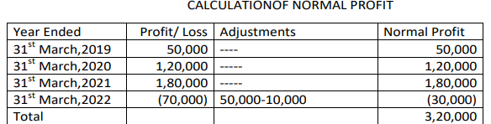  Average profit = 320000/4 = 80,000  Firm’s goodwill = 80,000 X 2 = 1,60,000  Sac/gain = 160000 X 1/6 = 26,667  Journal entry  Ron’s capital a/c dr 26,667  To Don’s capital a/c 26,667  (goodwill adjusted at the time of change in psr) |  | 2+1
21 | Balance Sheet of Khanna Ltd.  Notes to Accounts:  - Share Capital  Authorized capital  2,00,000 equity shares @Ras 10 each 20,00,000  Issued capital  1,80,000 Equity shares @Rs.10 each 18,00,000  Subscribed & not fully paid up  1,68,000 shares @Rs.10 each, Rs8 called up 13,24,000  2,000 shares @Rs.10 each, Rs8 called up 16,000  Less:calls in arrears 4,000 12,000 |  | 1+32
  Particulars | Note no | Current year | Previous year
  - Equities & Liabilities  - Shareholders’ funds  - Share capital | 1 | 13,36,000
22 | Journal entries: |  | ½ + 1 + 1.5+1
  Date | Particulars | Dr. | Cr.
  a) | Realization a/c  To cash a/c | 15,000 | 15,000
  b) | Realization a/c  To Srividya’s capital a/c  No entry for realization expenses | 3,000 | 3,000
  c) | Workmen compensation reserve a/c  To Realization a/c  To Nehal’s capital a/c  To Pavithra’s capital a/c  To Srividya’s capital a/c  Realization a/c  To Cash a/c | 40,000  24,000 | 24,000  6,000  6,000  4,000  24,000
  d) | Nehal’s capital a/c  Pavithra’s capital a/c  Srividya’s capital a/c  To Realization a/c | 12,000  12,000  8,000 | 32,000
23 | Share capital a/c 1,00,000  To Calls in arrears a/c 30,000  To Forfeited shares a/c 70,000  Bank a/c 40,000  Forfeited shares a/c 10,000  To share capital a/c 50,000  Forfeited shares a/c 25,000  To capital reserve 25,000  OR  a)Share capital a/c 1,500  SPR a/c 750  To Calls in arrears a/c 1,950  To Forfeited shares a/c 300  Bank a/c 1,400  To share capital a/c 1,000  To SPR a/c 400  Forfeited shares a/c 200  To capital reserve 200  b) Share capital a/c 21,000  To Calls in arrears a/c 6,000  To Forfeited shares a/c 15,000  Bank a/c 20,000  To share capital a/c 20,000  Forfeited shares a/c 10,000  To capital reserve 10,000 |  | 6
24 | Revaluation account  Partners’ Capital accounts  OR |  | 6
  To Stock 20000  To Furniture 18000 | By Loss  Rajat 26600  Ravi 11400 38000
  Total 38000 | Total 38000
   | Rajat | Ravi | Rohan |  | Rajat | Ravi | Rohan
  Rev | 26600 | 11400 |  | Bal b/d | 100000 | 80000
  Cash | 875 | 375 |  | Cash |  |  | 60000
  Cash |  | 20225 |  | Premium | 1750 | 750
  Bal c/d | 126000 | 54000 | 60000 | Rohan’s current | 5250 | 2250
   |  |  |  | P&L a/c | 7000 | 3000
   |  |  |  | Cash | 39475
   | 153475 | 86000 |  |  |  | 86000
  Dr. REVALUATION ACCOUNT Cr.
  Particulars |  |  | ` |  | Particulars |  |  | `
  To Machinery A/c |  |  | 4,900 |  | By Freehold Premises A/c |  |  | 8,000
  To Furniture |  |  | 3,600 |  | By Stock |  |  | 3,000
  To Prov. for DD |  |  | 1,000
  To Prov. for discount |  |  | 500
  To Profit*
  Rajan's Capital A/c 400
  Babban's Capital A/c 400
  Aman's Capital A/c 200 |  |  | 1,000
   |  |  | 11,000 |  |  |  |  | 11,000
  Partners Capital Account
  Particulars | Rajan | Babban |  | Aman |  | Particulars | Rajan |  | Babban |  | Aman
  To Goodwill | 6,000 | 6,000 |  | 3,000 |  | By Balance b/d | 80,000 |  | 60400 |  | 60,000
  To Rajan's Capital A/c |  | 4,000 |  | 4,000 |  | By Gen. Reserve | 4,000 |  | 4,000 |  | 2,000
  To Rajan's Loan A/c | 86,400 |  |  |  |  | By Revaluation Profit | 400 |  | 400 |  | 200
  To Balance c/d |  | 66,000 |  | 44,000 |  | By Babban's Capital A/c | 4,000
  To Aman's Current A/c |  |  |  | 11,200 |  | By Aman's Capital A/c | 4,000
   |  |  |  |  |  | By Babban's Current A/c |  |  | 11,200
   | 92,400 | 76,000 |  | 62,200 |  |  | 92,400 |  | 76,000 |  | 62,200
25 | 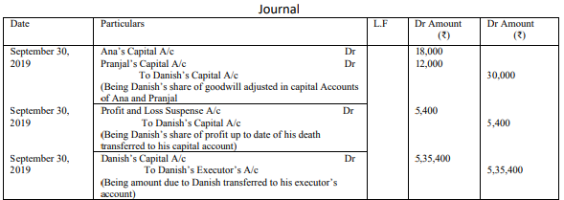  Working Notes:- Sales = 2,00,000 + 20% of 2,00,000 = 2,00,000 +40,000 Profit % = 10% - 1% = 9% Danish’s Share of Profit =₹ 2,40,000 X 9/100 X 5/10 X 6/12 = ₹ 5,400  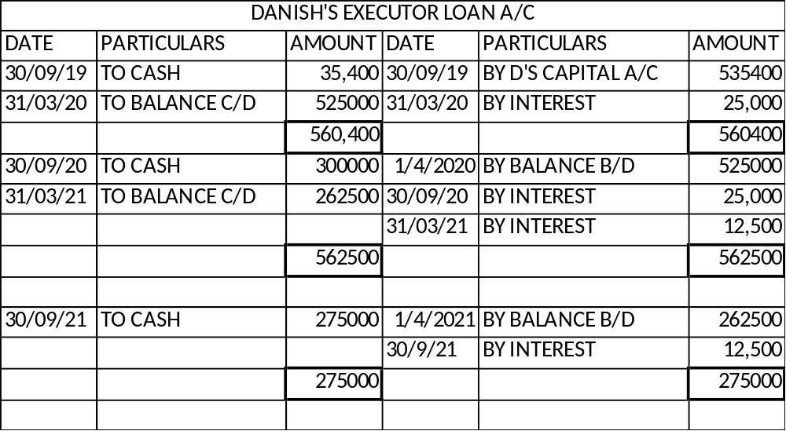 |  | 6
26 | a)Amount received at the time of allotment = 92,120  b) journal entry:  Share Capital A/c Dr. 5,000  Securities Premium Reserve A/c Dr. 500  To Share Allotment A/c 1,880  To Share First call A/c 1,500  To Share Final Call A/c 1,000  To Forfeited Shares A/c 1,120  c)Amount transferred to capital reserve = 48 |  | 2+3+1
 | PART B-ANALYSIS OF FINANCIAL STATEMENTS
27 | a(iii), b(i), c(iv), d(ii) |  | 1
28 | B |  | 1
29 | D |  | 1
30 | C |  | 1
31 | 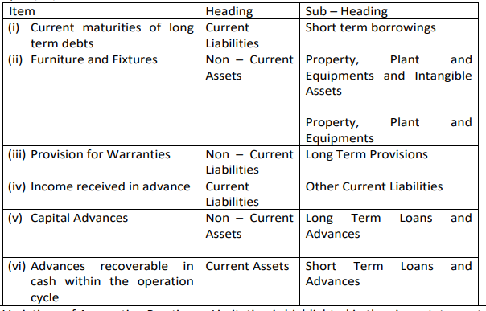 |  | ½ mark each 3
32 | For measuring the long-term solvency of any business we calculate the following ratios. Debt Equity Ratio:  1. Debt equity ratio indicates the relationship between the external equities or outsiders’ funds and the internal equities or shareholders’ funds. It is also known as external internal equity ratio. It is determined to ascertain soundness of the long-term financial policies of the company.  2. Proprietary Ratio and Total Assets to Debt Ratio: Total assets to Debt Ratio or Proprietary Ratio are a variant of the debt equity ratio. It is also known as equity ratio or net worth to total assets ratio. This ratio relates the shareholder’s funds to total assets.  3. Interest Coverage Ratio: This ratio deals only with servicing of return on loan as interest. This ratio depicts the relationship between amount of profit utilize for paying interest and amount of interest payable. A high Interest Coverage Ratio implies that the company can easily meet all its interest obligations out of its profit. |  | 3
33 | Capital Employed Turnover Ratio =  Revenue from Operations /Net Assets or Capital Employed  = 75,00,000/5000000=1.5 Times  Revenue from Operations= 75,00,000 (Given)  Capital Employed (Note) - Shareholders' Funds + Long-term Borrowings  working capital turnover ratio = RFO/working capital = 75,00,000/15,00,000 = 5 times  Working capital = 25,00,000 – 10,00,000  OR  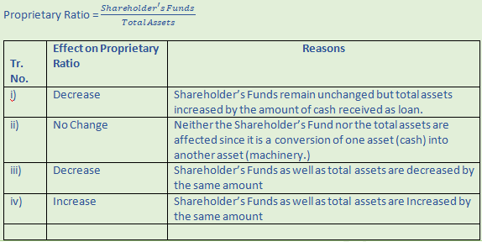 |  | 2+2  Or  1 each
34 | - Cash flow from investing activities:  - Cash flow from Financing activities |  | 3+3
  Particulars | Amount
  Purchase of investment | (4,50,000)
  Interest received on investment | 71,000
  Purchase of goodwill | (2,35,000)
  Sale of 12% investment | 2,80,000
  Interest received on 12% investment | 1,80,000
  Sale of patents | 1,60,000
  Sale of plant | 50,000
  Purchase of plant | (3,38,000)
  Cash used in investing activities | (4,44,000)
  Particulars | Amount
  Proceeds from issue of shares with premium | 2,50,000
  Redemption of preference shares with premium | (2,10,000)
  Proceeds from issue of debentures | 1,00,000
  Interim dividend paid | (60,000)
  Preference dividend paid | (60,000)
  Interest on debentures paid | (48,000)
  Cash used in Financing activities | (28,000)

